C219 Front-end Web Development

**Lesson 1**

Worksheet

Understanding the Problem

1. What is the main reason Little Toy Kingdom wants to set up an online store?
2. What information would they need before creating an online store?

The Web Design Process

1. What are the steps involved in a web design process / workflow? Fill in the table below with the web design process stages and their description.

|  |  |
| --- | --- |
| **Web Design Process** | **Description** |
| Gather Information | Gathers all relevant information. This lays the groundwork for the following processes. This information can be about the products, competitors and the consumers. |
| Make a Plan | Takes in all the information gathered and putting it into cycle which the entire process will follow. This is done by separating the information to different sections for design, content and programming. |
| Implement and Develop | There are three different sections: Design (wireframes), Programming (functional/system development) and Content Creation (content is written and optimised). |
| Testing | Multiple testing rounds will be conducted by the development company in a staging environment before access is given to the ordering client. |
| Launch the Website | The project should be set up and ready for installation. |

The Principles of Design

1. Recall the principles of design you have learnt from T252 Fundamentals of Design. List them below and describe what they mean.

|  |  |
| --- | --- |
| **Principles of Design** | **Description** |
| Emphasis | It Is the part of the design that catches that viewer’s attention |
| Balance and Alignment | It is the distribution of the visual weight of objects, colours, texture, and space. |
| Contrast | It is the use of visually different elements. |
| Repetition | It is the same or similar element used again. |
| Proportion | It refers to the relationship between one part of a design and another part or to the whole design |
| Movement | It refers to the path the viewer’s eye takes through the work of art, often to focal areas. |
| Rhythm | It suggests movement or action. |

1. Can these principles be applied to web design? Explain.

The Principles of Web Design

1. Conduct your own research and derive some principles of web design. Fill in the table below with the principles of web design together with an explanation.

|  |  |
| --- | --- |
| **Principles of Web Design** | **Description** |
| Use readable and web-friendly fonts | Typography plays a huge importance in web design. When the right fonts are used, it can accentuate the brand personality and capture the audience’s attention. |
| Use the ‘F’/ ‘Z’ pattern | Both the ‘F’ and ‘Z’ patterns are common eye-scanning patterns, from left to right. |
| Use negative space | Filling in empty areas (also known as blank/ white spaces) can help to draw attention to important content. |
| Have simple navigation | A well-designed website can allow for users to have a smooth experience while browsing the website. |
| Use a complementary colour palette | Colour palettes help in setting the mood of a website. Different colour palettes can be used for different target audiences. |
| Maintain visual hierarchy | Content has to be structured in order for it to make sense to users. |

Parts of a Web Page

1. What are the various parts of a web page? List them in the table below and describe them. Include a screenshot of a web page and label the parts.

|  |  |
| --- | --- |
| **Parts of a Web Page** | **Description** |
| Header or banner | Header is the uppermost part contains brand’s logo, website menu and navigation bar(webpages).  Located at the top of a webpage. It can include the company logo, a title and sometimes a search box for the site. The header usually stays consistent for all webpages on a website. |
| NAVIGATION | These are usually placed below the Header/Banner bar. The Navigation Bar lets you check out other pages on the website quickly and easily, as it is available to you no matter which page you are accessing. |
| Side bar | Provides additional content, navigation or display ads. Not all webpages have sidebars. |
| Website content | Content typically means the words written or explanation about the website that how site visitors can take advantage .  Content can also mean one word that is placed on buttons. |
| footer | Bottom part of any site .it includes sitemap with link pages, basic information to enabling users to find your storefront, and include social bar that contains small but recognizable icons. |

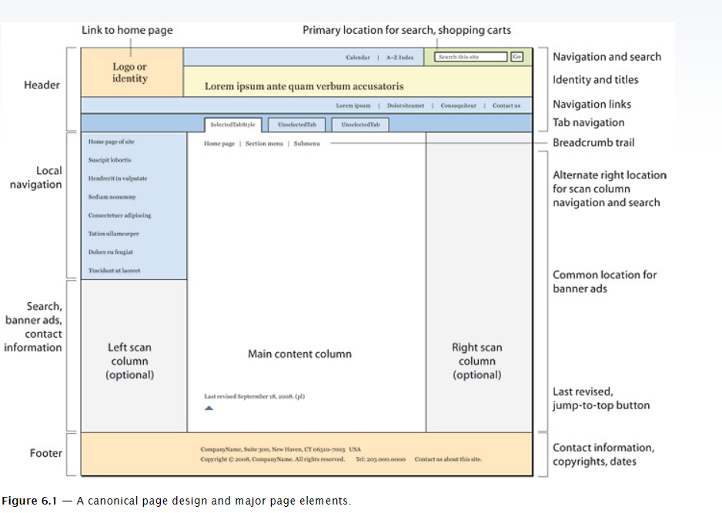

Website Analysis

1. Study [Shopee.sg](https://shopee.sg/). What is the main objective of this website?

This website is a retailer website which provides the user with a variety of products ranging from Mobile and Gadgets to Pet Foods and supplies.

1. Is this website a good example for Little Toy Kingdom to emulate? Why?

In my opinion, the website is not the best example for Little Toy Kingdom to emulate. My reasoning is that this website offers different types of products while Little Toy Kingdom only offers a variety of toys, the website’s front page shows many different offers, discounts and vouchers for different products while Little Toy Kingdom only aims to provide online purchasing from their store.

1. List a few effective websites for Little Toy Kingdom to refer to for inspiration. Provide reasons for your choices. You can list as many websites as you like.

|  |  |
| --- | --- |
| **Websites** | **Reasons** |
| [Toys"R"Us Singapore Official Website (toysrus.com.sg)](https://www.toysrus.com.sg/) | Toys”R”Us is a physical store that specialises in selling toys for children, the website provides many features like filters based on age and toy type, the website itself looks very simple using a blue/white theme which appeals to children. |
| [Toys For Kids | Children's Toys & More | The Entertainer (thetoyshop.com)](https://www.thetoyshop.com/) | Thetoyshop.com is an online shop that specialises in selling toy products, there is a header that allows the user to filter the type of product they are searching for. The website also shows top types of product filters. |

** Exercise 1 – Web Page Creation (Individual Work)**

1. Apply your prior knowledge in HTML and CSS to create a two-page website with the following key requirements:
   1. Page 1 – About Me
      * A heading
      * An image of yourself
      * A section containing information about you
   2. Page 2 – My Fav Food
      * A heading
      * An image of your favourite food
      * A short description about the food

Both pages should link to one another. You are not allowed to use any framework or template. You may add any other content that will enhance your web pages. Refer to [https://www.w3schools.com](https://www.w3schools.com/) for HTML and CSS tutorials.

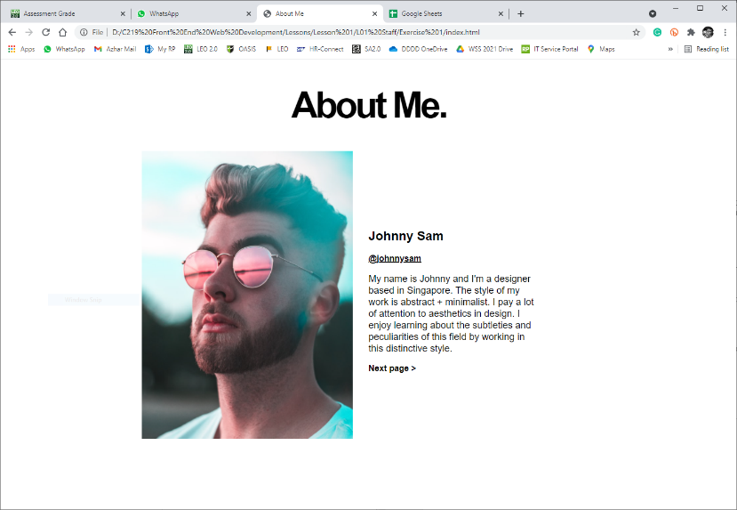

Page 1 Example

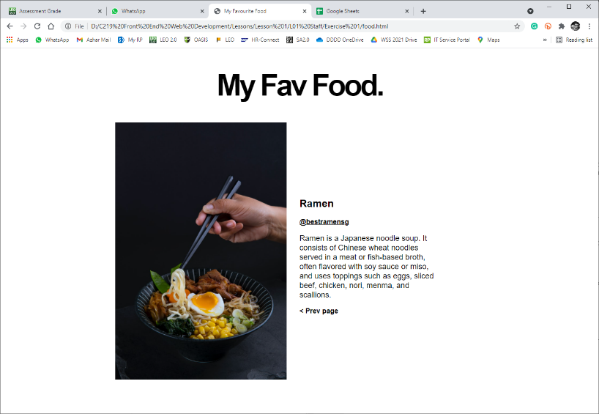

Page 2 Example

 **Solving the Problem (Teamwork)**

1. Create a website containing the information below:
   1. The principles of web design
   2. The parts of a web page
   3. A complete plan for the development of Little Toy Kingdom’s online store. You are to include details on the various stages in the web design process together with a project schedule / timeline.
   4. Two website examples for Little Toy Kingdom’s reference. Provide screenshots and reasons for your choices.

You may add more pages where necessary. You are not allowed to use any framework or template.

 **Deliverables**

Individual submission:

* Exercise 1

Team submission*:

* Worksheet
* Website^

* To be submitted by team leader only

^ Indicate your name on the web page(s) that you did

**Submit all deliverables by 3pm today.**